**Autonomous Flowchart**

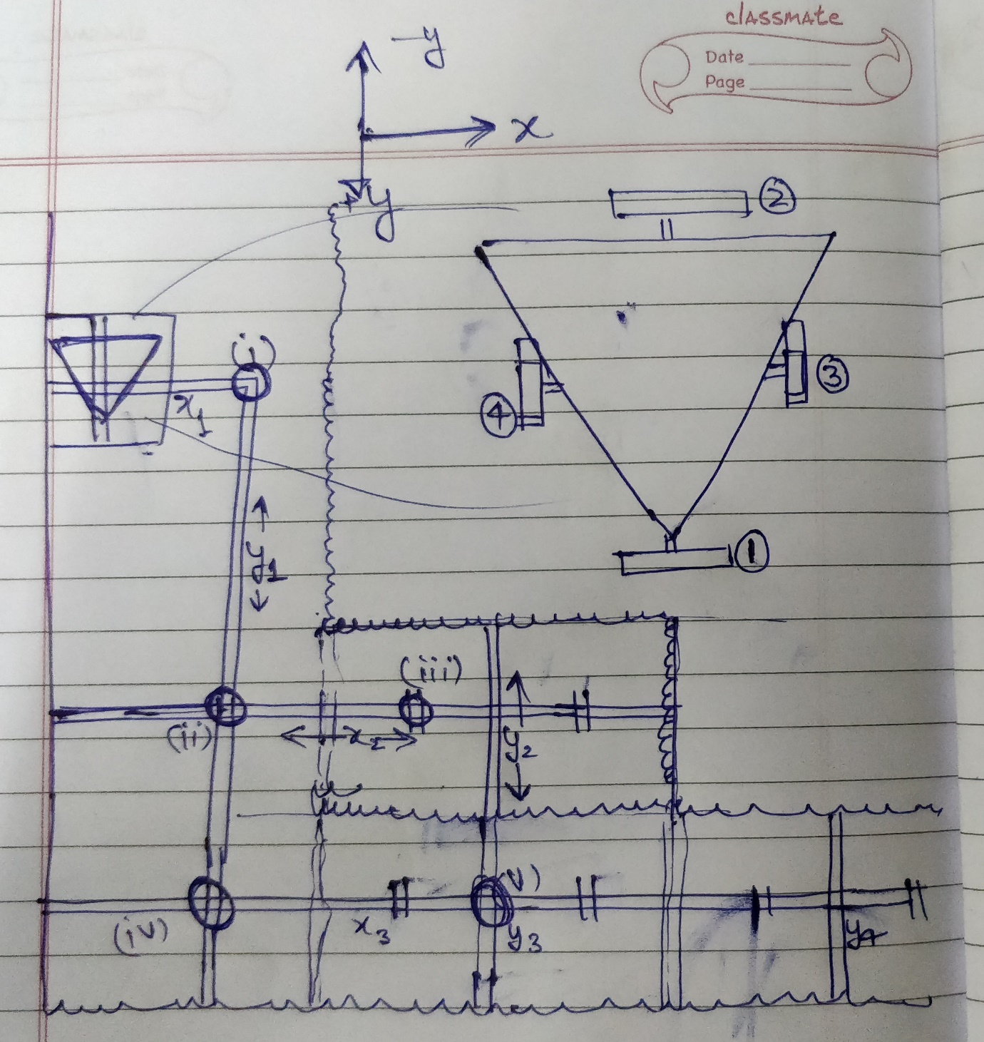

1. Move in +x with [3] and [4] on x1
2. [3] detects junction (i)
3. Move in a straight line along +x – direction till [1] detects line y1 at super slow speed
4. Move in a straight line along +y direction until [2] detects line y1 at slow speed
5. Follow y1 with [1] and [2]
6. Start decelerating at appropriate distance using y-encoder
7. Detect junction (ii) with [1]
8. Move along +y direction until [3] and [4] detect line x2 at super slow speed
9. Follow x2 with [3] and [4]
10. Detect junction (iii) with [3]. Reset x-encoder.
11. Move towards TZ1 back wall in +y direction till one of the limit switches closes.
12. Align to the wall by rotating in appropriate direction.

LOADING AND THROWING

1. Move towards x2 in -y direction at slow speed
2. Detect x2 with [3] and [4]
3. Follow line y1 along -x direction with [3] and [4]
4. Detect junction (ii) with [4]
5. Move in a straight line along -x direction till [2] and [1] detect y1 at super slow speed
6. Follow y1 with [1] and [2]
7. Detect junction (iv) with [1]
8. Move in straight line in +y direction till [3] and [4] detect x3 at super slow speed
9. Follow x3 with [3] and [4]
10. Detect junction (v) with [3]
11. Move towards TZ2 front wall in -y direction till one of the limit switches closes.
12. Align with TZ2 wall by rotating in appropriate direction.

LOADING AND THROWING

LOAD GOLDEN RACK